RTL-to-GDS Physical Design Flow
Using Cadence Innovus with SKY130 Standard Cell Library

Prepared by:
SIAM AL SHAFIN
March 13, 2026
Tool: Cadence Innovus 21.18 | Technology: SKY130 | EDA Flow: RTL-to-GDS

1. Project Overview
This report documents the complete RTL-to-GDSII digital ASIC physical design flow implemented using the Cadence Innovus physical design tool and the SKY130 open-source standard cell library. The project demonstrates all major stages of a backend ASIC design implementation, starting from a synthesized Verilog gate-level netlist and concluding with a fully routed GDSII layout file suitable for fabrication.

1.1 Project Objectives
- Implement a complete RTL-to-GDS backend physical design flow
- Utilize the Cadence Innovus 21.18 physical design tool
- Target the SKY130 130nm standard cell technology library
- Transform a synthesized Verilog netlist into a manufacturable GDSII file
- Demonstrate all key ASIC backend stages: floorplanning, power planning, placement, CTS, routing

1.2 Design Flow Summary
The complete flow covered the following stages in sequence:
- Library Setup — LEF, LIB, and GDS mapping file preparation
- Design Initialization — Loading netlist, technology files, and timing constraints
- Floorplanning — Core area definition and placement row configuration
- Power Planning — Power ring and stripe creation for VDD/VSS distribution
- Placement — Standard cell placement and pre-CTS timing optimization
- Clock Tree Synthesis (CTS) — Clock buffer/inverter insertion for uniform clock distribution
- Routing — Multi-layer signal routing across 5 metal layers
- Layout Generation — GDSII export of the final physical layout

2. RTL Design Description
The design implemented in this project is a 32-bit ALU (Arithmetic Logic Unit) with registered inputs. The top-level module, named top, wraps the ALU with input pipeline registers to improve timing closure and follows standard synchronous design methodology.

2.1 Top-Level Module
The top module serves as the entry point for the physical design flow. It includes:
- A 32-bit input operand A (a[31:0]) — registered on the positive clock edge
- A 32-bit input operand B (b[31:0]) — registered on the positive clock edge
- A 3-bit operation selector (op[2:0]) — registered on the positive clock edge
- A 32-bit output Y (y[31:0]) — driven directly by the ALU output

2.2 RTL Source Code
The Verilog RTL code for the top module is shown below:

module top(
input clk,
input [31:0] a,
input [31:0] b,
input [2:0] op,
output [31:0] y
);
reg [31:0] a_reg;
reg [31:0] b_reg;
reg [2:0] op_reg;
wire [31:0] alu_out;

always @(posedge clk) begin
a_reg <= a;
b_reg <= b;
op_reg <= op;
end

alu u_alu (
.a(a_reg),
.b(b_reg),
.op(op_reg),
.y(alu_out)
);
assign y = alu_out;
endmodule

2.3 Design Architecture
The design follows a pipelined register-then-compute architecture. The three input signals (a, b, op) are captured by flip-flop registers on the rising edge of the clock before being fed into the combinational ALU block. This register stage improves timing by isolating the ALU combinational path from upstream logic. The ALU output is then passed directly to the primary output y.

3. Tools and Technology Libraries

3.1 Tools Used

Tool | Version | Purpose
Cadence Genus | 21.18-s082_1 | Logic Synthesis
Cadence Innovus | 21.18 | Physical Design (P&R)
SKY130 PDK | 1.0 | Process Design Kit
TCL Scripts | — | Flow Automation

3.2 Library Files
File Type | File Name | Purpose
Technology LEF | sky130_scl_9T.tlef | Metal layer & via definitions
Standard Cell LEF | sky130_scl_9T.lef | Cell dimensions & pin locations
Timing Library | sky130_tt_1.8_25_nldm.lib | Timing & power characterization
GDS Map File | sky130_stream.mapFile | GDS layer mapping for export
Verilog Netlist | top_netlist.v | Gate-level netlist from synthesis
SDC Constraints | top.sdc | Clock & timing constraints

4. Project Structure
The project was organized under a working directory named shafin with the following folder structure:

shafin/
├── rtl/
│ └── top.v
├── libs/
│ ├── lef/ (sky130_scl_9T.lef, sky130_scl_9T.tlef)
│ ├── lib/ (sky130_tt_1.8_25_nldm.lib)
│ └── gds/ (sky130_stream.mapFile)
├── scripts/
│ ├── innovus.tcl
│ └── mmmc.tcl
├── constraints/
│ └── top.sdc
└── layout/
├── top.enc
├── top.enc.dat
└── top.gds

5. Synthesis Results
Logic synthesis was performed using Cadence Genus Synthesis Solution 21.18-s082_1 prior to the physical design flow. The synthesized netlist was then imported into Cadence Innovus for physical implementation.

5.1 Area Report
Parameter | Value
Module | top
Technology Library | sky130_tt_1.8_25 1.0
Operating Conditions | tt_1.8_25 (balanced_tree)
Cell Count | 356
Cell Area | 6027.695
Net Area | 0.000
Total Area | 6027.695

The following screenshot shows the actual area report generated by Cadence Genus after synthesis:

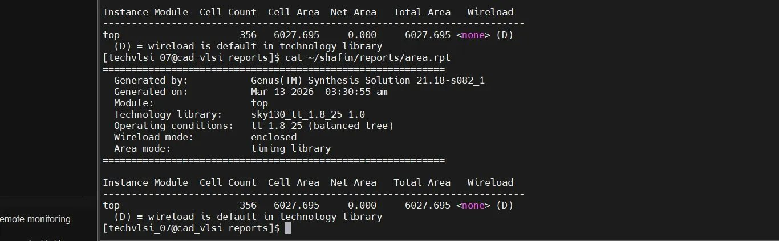
Figure 1: Post-Synthesis Area Report (Cadence Genus)

5.2 Timing Report
The timing analysis was performed at the typical-typical (tt) corner at 1.8V, 25°C. The critical path runs through a ripple-carry adder chain composed of ADDFX1 full adder cells.

Parameter | Value
Clock Period | 10,000 ps (10 ns)
Data Path Delay | 7,510 ps
Output Delay | 2,000 ps
Required Time | 8,000 ps
Slack | +490 ps (MET)
Timing Status | TIMING MET
Startpoint | op_reg_reg[1]/CK
Endpoint | y[31]
Critical Path Type | Ripple Carry Adder (ADDFX1 chain)

The positive slack of 490 ps confirms that all timing constraints were met after synthesis. The screenshots below show the full timing report as generated by Cadence Genus:

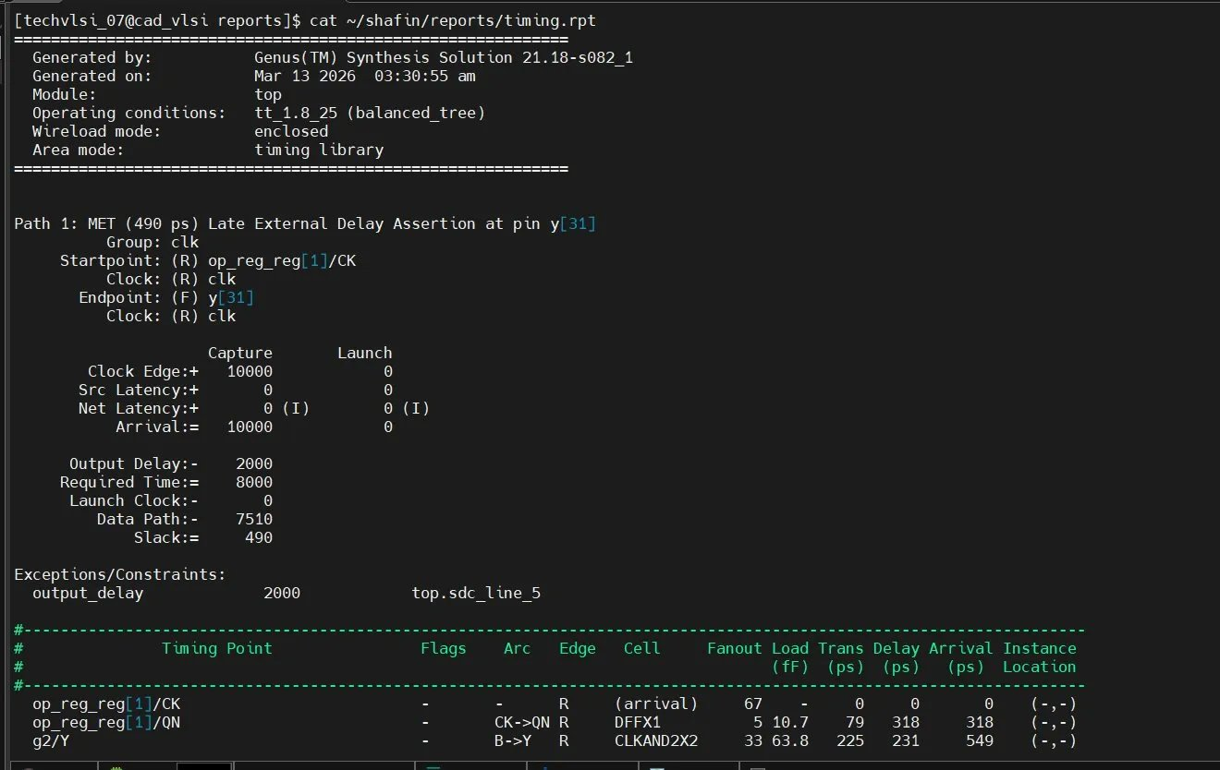
Figure 2: Post-Synthesis Timing Report — Critical Path Summary (Cadence Genus)

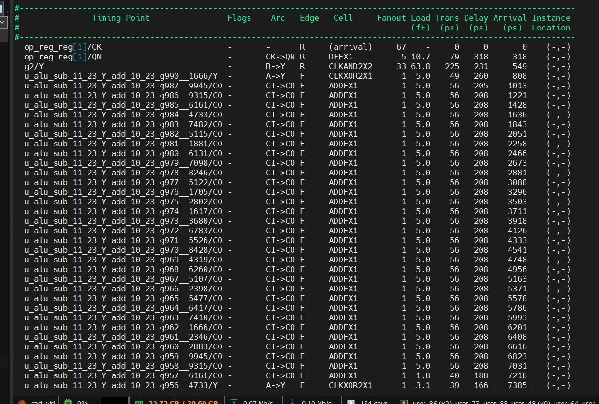
Figure 3: Post-Synthesis Timing Report — Critical Path Detail (ADDFX1 Carry Chain)

5.3 Power Report
Post-synthesis power analysis was performed using Genus with default switching activity. Total power consumption is approximately 572.3 µW, with registers being the dominant consumer at 63.82%.

Category | Leakage (W) | Internal (W) | Switching (W) | Total (W) | Row %
Register | 1.32e-07 | 3.26e-04 | 3.94e-05 | 3.65e-04 | 63.82%
Logic | 1.11e-07 | 9.79e-05 | 6.89e-05 | 1.67e-04 | 29.16%
Clock | 0 | 0 | 4.02e-05 | 4.02e-05 | 7.02%
Memory/Latch/Pad | 0 | 0 | 0 | 0 | 0.00%
Subtotal | 2.43e-07 | 4.24e-04 | 1.49e-04 | 5.72e-04 | 100%
Percentage | 0.04% | 74.01% | 25.95% | 100% | —

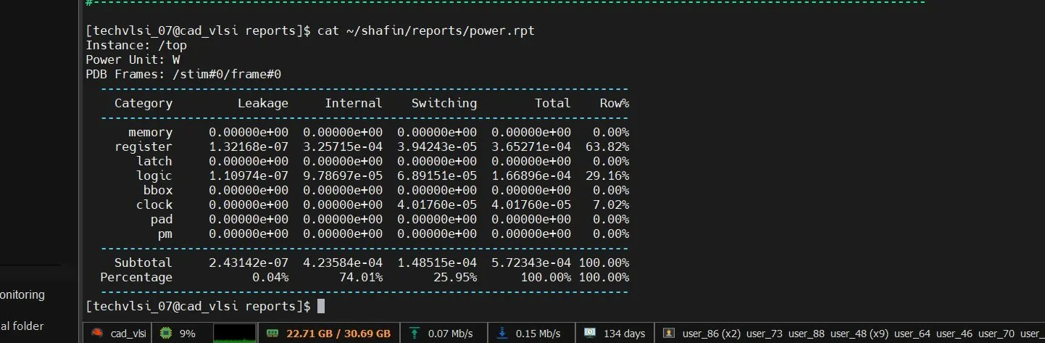
Figure 4: Post-Synthesis Power Report (Cadence Genus)

6. Physical Design Flow

6.1 Design Initialization
The Innovus script began by loading all required library and design files into the Innovus database.

set init_ignore_pgpin_polarity_check true
set init_pwr_net {VDD}
set init_gnd_net {VSS}
set init_lef_file {../libs/lef/sky130_scl_9T.tlef ../libs/lef/sky130_scl_9T.lef}
set init_verilog ../layout/top_netlist.v
set init_top_cell top
set init_mmmc_file ../scripts/mmmc.tcl
init_design
setDesignMode -process 130

6.2 Floorplanning
The floorplanning stage defined the core layout region where standard cells are placed and the overall chip boundary.

floorPlan -site CoreSite -r 1.0 0.7 10 10 10 10

A core utilization of 70% was used with 10-micron margins on all sides. This command also defined the placement rows that standard cells are aligned to during the placement stage.

6.3 Power Planning
Power planning created a robust power distribution network for VDD and VSS across the entire chip.

Global Net Connection
globalNetConnect VDD -type pgpin -pin VDD -all
globalNetConnect VSS -type pgpin -pin VSS -all
applyGlobalNets

Power Ring Creation
addRing -nets {VDD VSS} -type core_rings \
-layer {top met5 bottom met5 left met4 right met4} \
-width 2 -spacing 1 -offset 2

Power Stripe Creation
addStripe -nets {VDD VSS} -layer met4 -direction vertical \
-width 1 -spacing 2 -set_to_set_distance 20

6.4 Placement
Standard cells were placed inside the floorplan using the Innovus placement engine, followed by pre-CTS timing optimization.

placeDesign
optDesign -preCTS

6.5 Clock Tree Synthesis (CTS)
CTS inserted clock buffers and inverters to distribute the clock signal uniformly to all 67 flip-flop sinks in the design.

set_ccopt_property buffer_cells {BUFX2 BUFX4 BUFX8 CLKBUFX2 CLKBUFX4 CLKBUFX8}
set_ccopt_property inverter_cells {INVX1 INVX2 INVX4 CLKINVX1 CLKINVX2 CLKINVX4}
ccopt_design
optDesign -postCTS

The screenshots below show the Innovus CTS log output:

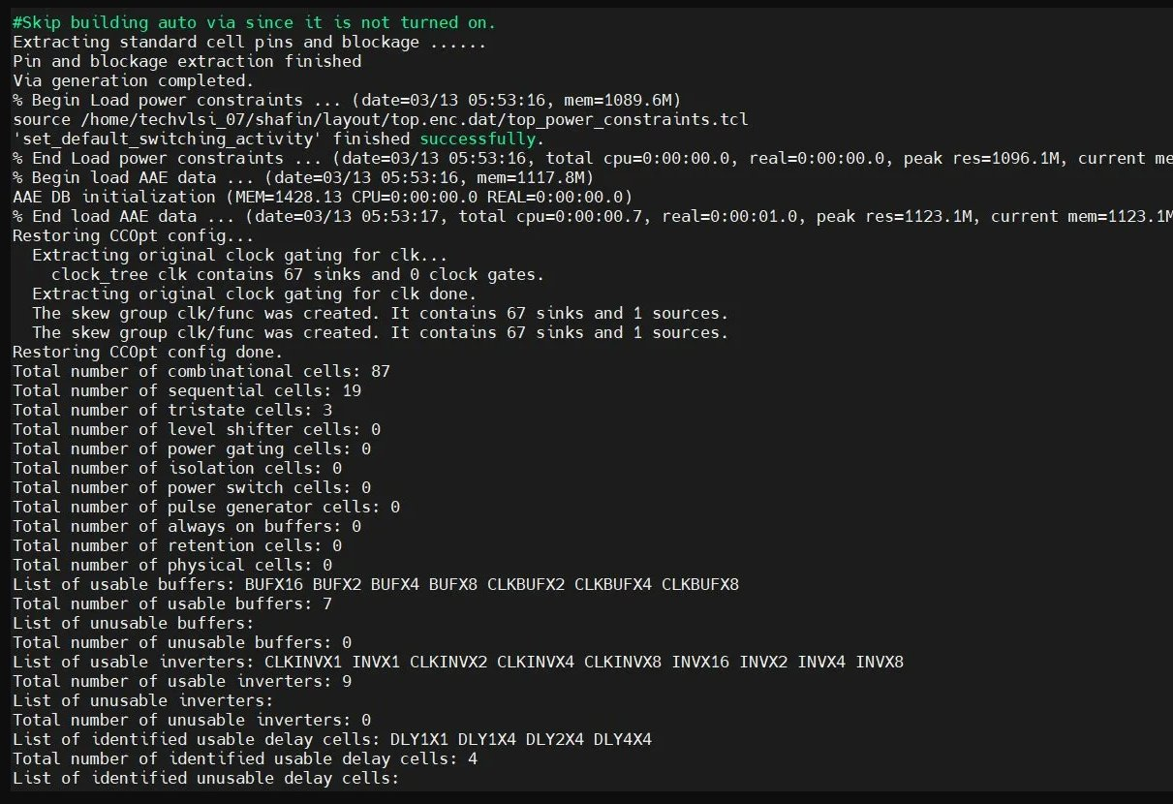
Figure 5: Clock Tree Synthesis Log — CTS Cell Statistics and Buffer/Inverter Library

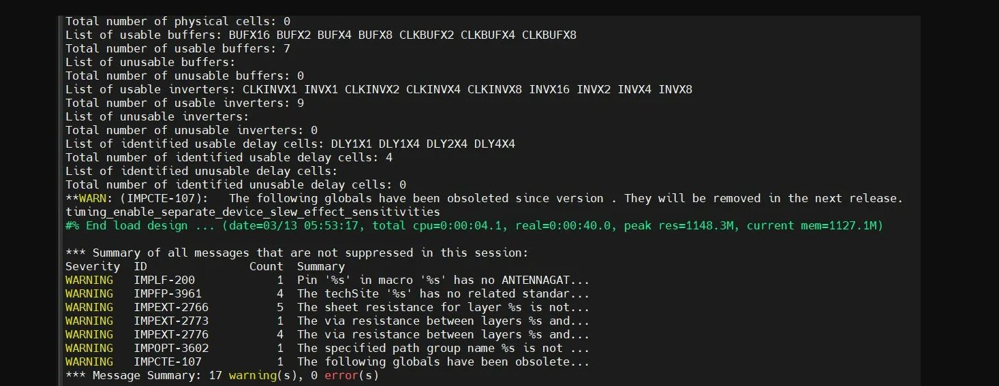
Figure 6: Final Session Log — Warning Summary (17 Warnings, 0 Errors)

CTS Results Summary
Parameter | Value
Clock Signal | clk
Total Clock Sinks | 67
Clock Sources | 1
Clock Gates | 0
Skew Group | clk/func
Usable Buffers | 7 (BUFX2/4/8, CLKBUFX2/4/8, BUFX16)
Usable Inverters | 9 (INVX1/2/4/8/16, CLKINVX1/2/4/8)
Usable Delay Cells | 4 (DLY1X1, DLY1X4, DLY2X4, DLY4X4)
Sequential Cells | 19
Combinational Cells | 87

6.6 Routing
The routing stage connected all signal nets across five metal layers using the Innovus detail router.

routeDesign

- Metal 1 (met1) — Local cell-to-cell connections
- Metal 2 (met2) — Horizontal routing
- Metal 3 (met3) — Vertical routing
- Metal 4 (met4) — Power stripes and longer horizontal routes
- Metal 5 (met5) — Power rings and top-level routing

6.7 GDSII Export
After successful routing, the final layout was exported to GDSII format:

streamOut ../layout/top.gds

7. Physical Layout
The following images show the final routed physical layout of the top module as viewed in Cadence Innovus. The layout includes all 368 standard cells, 3701 nets, and 2147 via instances across 5 metal layers.

7.1 Full Chip Layout View
The image below shows the complete top-level view of the routed layout in Cadence Innovus, showing the full chip with all routing layers visible:

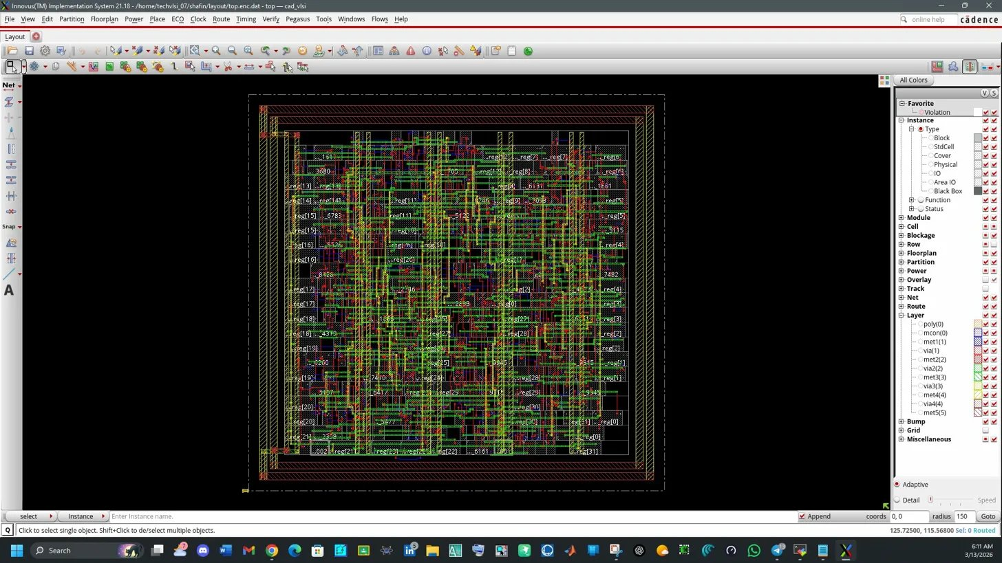
Figure 7: Full Chip Layout — Complete Routed View in Cadence Innovus (top module)

7.2 Zoomed Core Layout
The zoomed-in view below reveals the density of standard cell placement and routing within the chip core area:

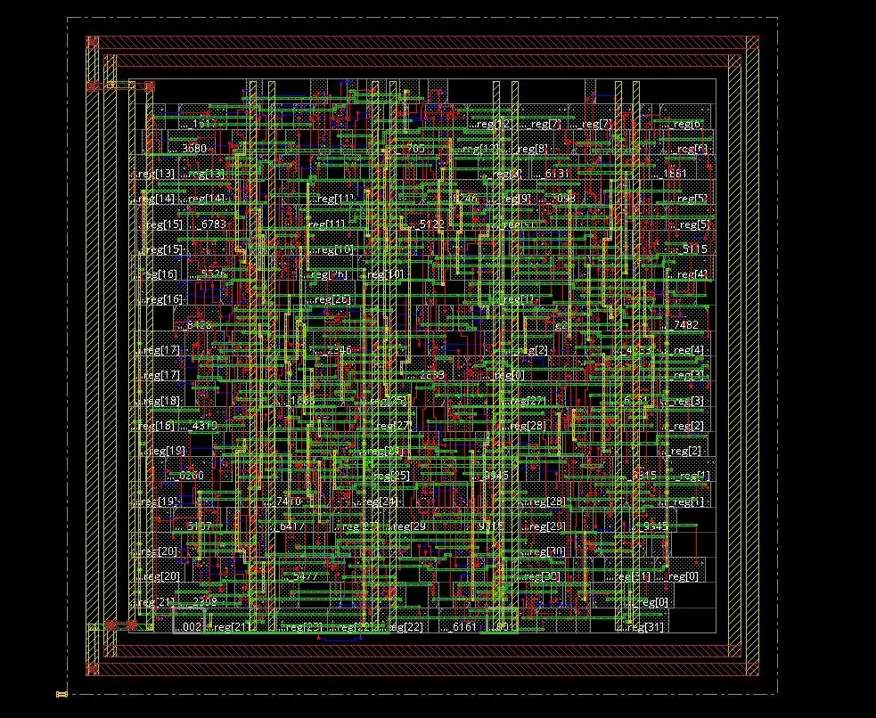
Figure 8: Zoomed Core Layout — Standard Cell Placement and Multi-Layer Routing

7.3 Detailed Routing View
The following close-up view shows individual nets, CTS clock buffers (CTS_3), power rails (VDD/VSS), and via connections between metal layers:

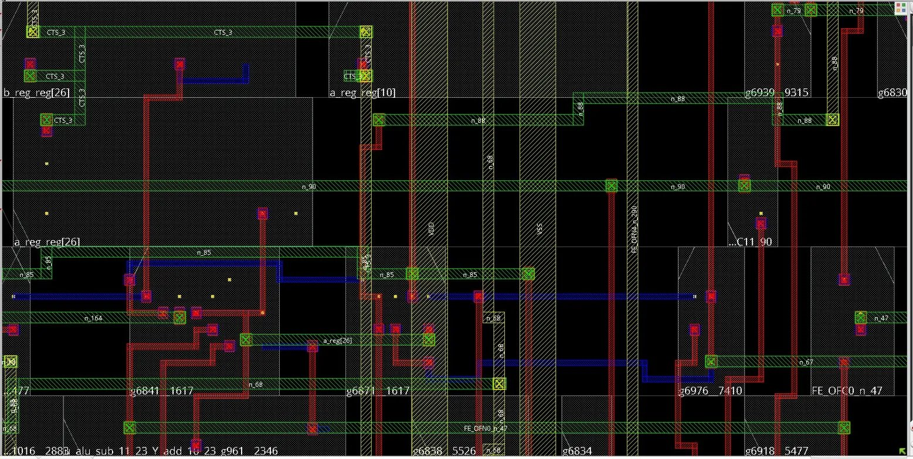
Figure 9: Detailed Routing View — CTS Buffers, Power Rails, and Via Connections

In the detailed view, the following key elements are visible:
- CTS_3 clock buffer cells (green boxes) distributed across the layout
- VDD and VSS vertical power rails clearly labeled
- Register instances: b_reg_reg[26], a_reg_reg[10], a_reg_reg[26]
- Via connections (green X markers) between metal layers
- Red routing (met2), blue routing (met3/met5), green routing (met1/met3)
- Feed-through cells: FE_OFN0, FE_OFC0

8. Problems Encountered and Solutions
Several errors and warnings were encountered during the implementation flow. Each was diagnosed and resolved as described below:

# | Problem | Error / Symptom | Solution Applied
1 | Power Nets Not Found | Global net 'VDD' does not exist | Explicitly defined: set init_pwr_net {VDD}, set init_gnd_net {VSS}
2 | Pin Polarity Mismatch | VSS pin and VSS net not of same polarity | Added: set init_ignore_pgpin_polarity_check true
3 | addRing Syntax Error | Incorrect command syntax for power ring | Corrected layer spec: {top met5 bottom met5 left met4 right met4}
4 | SI Optimization Error | AAE-SI requires OCV timing mode | Removed post-route SI optimization from script
5 | Filler Cell Error | No filler cell provided | Flow continued without filler insertion; no critical impact

9. Final Design Statistics

9.1 Physical Implementation Statistics
Parameter | Value
Standard Cells (Post-PD) | 368
Total Nets | 3701
Via Instances | 2147
Routing Metal Layers | 5 (met1 – met5)
Clock Sinks | 67
Final Warnings | 17
Final Errors | 0
Timing Status | MET (Slack: +490 ps)
Total Power | ~572.3 µW
Total Area | 6027.695

9.2 Output Files Generated
File | Description
top.gds | Final GDSII layout — primary fabrication deliverable
top.enc | Innovus design database (binary checkpoint)
top.enc.dat | Innovus design data directory
top_netlist.v | Gate-level Verilog netlist (from synthesis)

9.3 Warnings Summary
Warning ID | Count | Description
IMPLF-200 | 1 | Pin in macro has no ANTENNAGAT attribute
IMPFP-3961 | 4 | TechSite has no related standard site
IMPEXT-2766 | 5 | Sheet resistance for layer not defined
IMPEXT-2773 | 1 | Via resistance between layers not specified
IMPEXT-2776 | 4 | Via resistance between layers not specified
IMPCTE-107 | 1 | Obsolete global variable

All 17 warnings are non-critical and relate to missing technology file parameters or deprecated configuration variables. No errors were reported, confirming a clean and successful flow completion.

10. Conclusion
This project successfully demonstrated a complete RTL-to-GDSII ASIC physical design flow using Cadence Innovus and the SKY130 open-source standard cell library. Starting from a synthesized 32-bit ALU design, all major stages of the backend flow — floorplanning, power planning, standard cell placement, clock tree synthesis, and routing — were executed and completed successfully.

The final design met all specified timing constraints with a positive slack of +490 ps. Total power consumption was approximately 572.3 µW, dominated by register activity. The design was fully routed across 5 metal layers with 368 standard cells, 3701 nets, and 2147 via instances. The final GDSII file (top.gds) was generated and is ready for physical verification and tape-out.

This project provided comprehensive hands-on experience with the complete ASIC backend implementation process using industry-standard tools, demonstrating how digital circuits are physically implemented on silicon using the SKY130 130nm technology node.

References
- Cadence Innovus Implementation System 21.18 User Guide
- SkyWater SKY130 PDK Documentation — https://skywater-pdk.readthedocs.io
- Cadence Genus Synthesis Solution 21.18 User Guide
- SKY130 Standard Cell Library (sky130_scl_9T) Datasheet
- IEEE Standard for Verilog Hardware Description Language, IEEE Std 1364

